Final Exam
- What is the difference between a Robot Project and a Virtual Instrument?

A
features an enhanced interface that allows you to configure and
test your robot without a program, as well organize multiple program files in one place.

A
contains a single Front Panel and Block Diagram, and can be used
to create a single program and interface.

- For this question, refer to the two pictures below:
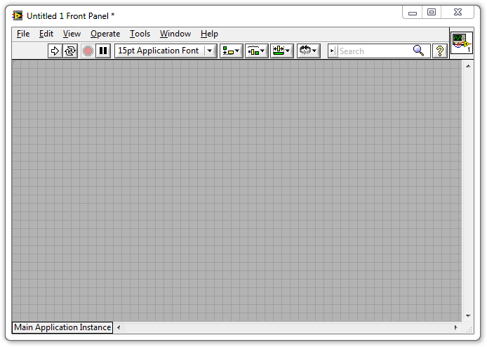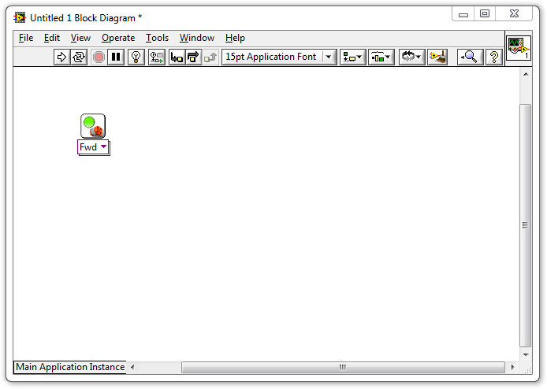
  - What is the window on the left with the grey background called?

The Block Diagram
The Main Menu
The Program Field
The Front Panel

  - What is the window on the right with the white background called?

The Block Diagram
The Main Menu
The Program Field
The Front Panel

  - Which window do you drag VIs into, to give the robot movement commands?

The Front Panel
The Program Field
The Block Diagram
The Code Schematic (not shown above)

- What is this called?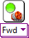

A Movement VI
A Motor Control VI
A Forward VI
The Block Diagram

- If you want to add a Motor VI to your program...
  - Where can you find one?

In the Tools Palette
In the Functions Palette
Type the word "Motor" and press enter
In bar on the left hand side of the screen

  - How do you add it to your program?

Double-click the Motor VI in the Functions Palette
Drag the Motor VI to the Front Panel
Drag the Motor VI to the Block Diagram

- How do you open the Functions Palette?

Right-click an empty area of the Block Diagram
Select Functions Palette from the View menu
Both of the above
None of the above

- What command does this block give the robot?

Forward a message to the robot
Turn the motors on in the foward direction
Wait for 1 second
Stop the motors

- What command does this block give the robot?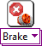

Make the robot fall apart
Turn the motors on in the foward direction
Wait for 1 second
Stop the motors

- What does the pink wire indicate in this program?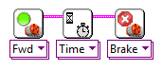

The blocks were dropped too close together
LabVIEW is currently running the commands
The commands will take place in order they are connected from left to right
This is the Primary Command Sequence for the robot

- The two blocks shown below were dropped far apart and did not auto-wire. How do you connect them?

Click their top corners and use the wiring tool to connect them
Drag them closer together until the auto-wire appears
Right-click the first block and select "Wire to Nearest"
You can't wire them together if you miss the first time

- Click the button in the picture below that Runs the program.

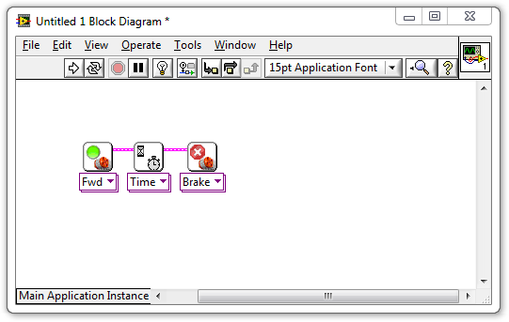
- What is a Constant (also called a Constant Modifier)?

A command that tells the robot to hold its position
Any command given to the robot that does not change its heading
Another name for a Variable Block
A "thing" representing a specific value, which can be wired into Blocks

- How do you set a motor to run for 5 seconds instead of 1?

Click the Motor Block and change the Duration setting to 5
Wire a Constant with a "5" in it into a Motor Block's "Time" port
Create a Constant with a "5" in it and drag it on top of the Motor Block
Drop a 5 Second Motor Block on the Block Diagram instead

- Where would you check to see what settings are available on a block and what they do?

Context Help window
Block Diagram
Front Panel
Main Menu
- Why didn't the program in the video work the first time it was run?

The Wait for Rotations Block was set to wait for the wrong motor
The Wait for Rotations block was set to wait for all the motors
The Wait For block was set to wait for Time instead of Rotations
The Motor Block's power was set too high

- 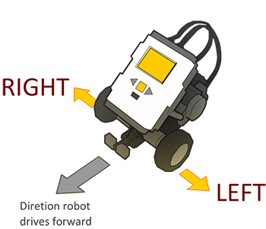
What ports are the robot's motors attached to on the default REM model?

Left Motor=A, Right Motor=B
Left Motor=B, Right Motor=C
Left Motor=C, Right Motor=B
Wheel Motors=C, Arm Motor=B

- Why are Rotations generally better than Time?

The robot's clock is inaccurate
The wheels spin more freely
Rotations always go the same distance regardless of speed or battery level
You cannot set the number of seconds the robot waits

- 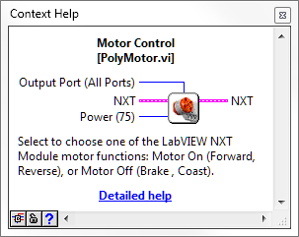
According to this picture from the Context Help menu, which of the following things can NOT be chosen on a Motor Block?

How long to keep the motors running
Which motor ports to give the command on
How much power to give the motors
All of the above can be set on the Motor Block

- Based on the same picture from the Context Help menu in question 4, what is the default value for the Power setting on the Motor Block?

75
100
All Ports
No default

- How do you make a program that can run on the NXT without needing to be hooked up to the main computer?

Select "Target to NXT" from the File menu
Select "Send to NXT" from the Tools Menu
Choose "Run on NXT" from the NXT's LCD screen interface
LabVIEW programs cannot be run that way

- Once you have deployed the program onto the NXT, how do you run it?

On the NXT: Program Files > Run
On the NXT: My Files > Software File > (Name of .VI file) > Run
On the PC/Mac: File > Run Deployed Program
On the NXT: grey button labeled "Run Deployed"
- A robot turns when...

Its wheels move in different direction of at different speeds
You use a Motor Block set to Turn
You move the Steering slider to the left or right of center
Its wheels move together at the same speed

- If the robot's left motor goes forward while its right motor goes in reverse, how will the robot's body move?

Turn to the left
Turn to the right
Move straight ahead
Make an outward spiral

- To make the robot turn...

Change "Fwd" to "Turn" on the Motor Block
Move the steering slider to the left or right
Make an outward spiral
Give its wheels different movement commands

- If you don't specify a motor, what does the Motor Block default to?

Motor/Port A
Motor/Port B
Motor/Port C
All motors/ports

- To specify which motors a Motor Block controls, you:

Attach a Constant modifier to the Output Ports node
Change "Fwd" to the name of the motor you want
Use a "Motor A Block" instead
Select the Motor Block and type the letter of motor you want (A, B, or C)

- How do you remove a wire?

Drag the blocks apart until the wire breaks
Click on the wire and press delete
Use the scissors tool to cut the wire
Hold down the mouse button and scratch it out

- What does the Sequence Structure do?

Let the program choose between multiple "frames" of code to run
Let the program repeat "frames" of code more than once
Let you hide code that you don't want to run
Allow "phases" of code to run in sequence even if individual phases involve parallelism
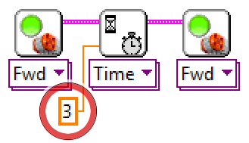
- What is the value of this Constant circled in red above?

0
3
4
No value

- How is the circled Constant being interpreted by the program?

As a command to wait
As number of port
As a number of rotations
As number of seconds

- Why is it being interpreted this way?

Because it is providing its value to the Wait Block
Because it is providing its value to the "Seconds" terminal on the Wait Block
All constants are interpreted the same way
Because the value is an integer

